Two weeks ago, **I walked away from my startup, and the Silicon Valley dream I’d been chasing for six years**, right in the middle of living it. Let me explain how I wound up here.

My name is **Siddharth**. I’m based in the UK, but I’ve dreamed of building in Silicon Valley since I was 13. When I finally visited at 13, I **dragged my uncle to every big tech campus**. Back then, I didn’t put too much thought into why I actually cared about building and startups, I just wanted to feel like Tony Stark.

Fast forward to today: I’m doing **CS @ Imperial College London**, first year left me extremely disillusioned with college, the course itself was terrible, there were few like-minded people, and it was uninspiring in general. So I wondered if I could just drop out and try to build a startup, people before me have done it, why can’t I?

**2 failed ideas later**, I came across the YC AI startup school event, I nearly didn’t apply. That would’ve been the **BIGGEST mistake** I’d ever made. Luckily, I sent off the application last minute and got in.

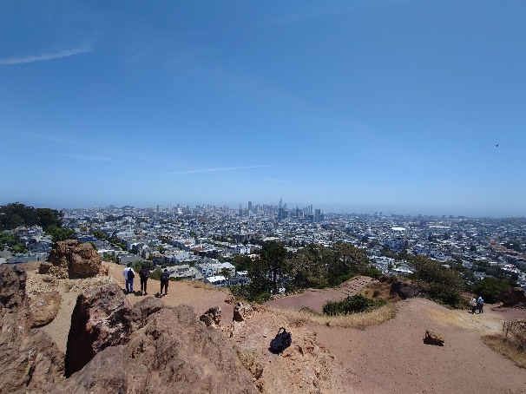



**Going to California changed literally everything.** I finally met people who spoke the same language as me (including my co-founder for the next 2 months, shoutout to Rono) and it was my first proper intro into the Silicon Valley startup world. Rono told me and Sourish to apply to **Founders Inc offseason**. We did our interview in the **car park outside startup school**, and 5 mins later, as we were assessing if the interview went well or not, we **got accepted into offseason**.

Pure **dopamine flooded every part of my body**, I was physically jumping up and down in the startup school! I was about to spend the summer **building a startup in Silicon Valley**! I had dreamed of this for the last 6 years.

Fast forward to **23rd June**, the start of offseason. My mindset going into the program was, “I must raise so I can drop out”, so I was **laser focused on Topaz**. It was simultaneously the **most fun and most stressed** I’ve ever been. Stressed because I wanted it to work so badly, and having fun while solving technical problems, all day and all night.

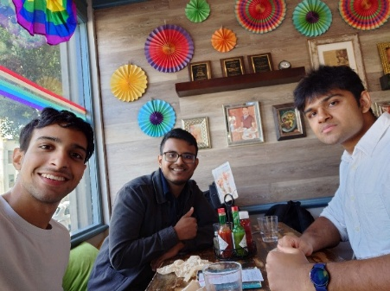

Being at Founders Inc was **incredibly inspiring** too, I met some lifelong friends and everybody around me was building the coolest shit. The F Inc team really did a good job of building a community and making it a friendly place.

So **why did I leave my startup then?** It was my dream coming true, I was in SF building a tech startup. Well, the thought of leaving never crossed my mind until around 3 weeks into the program. **I had 3 main reasons.**

The first one was that **I’ve lost my love for software**. Let me explain. There were many founders at F Inc building hardware, drones, robots, and everything in between. Before California, I built a **hardware EEG headband** that could tell if someone was focused or distracted. It was messy and challenging, a hands-on mix of electrodes, wires, and trial-and-error.

At Topaz, most of my work happened in my head, designing system architectures and algorithms and regurgitating it to Claude. **That’s when it hit me:** after spending my teens sharpening my coding skills, I didn’t enjoy pure software anymore. It was just not as fun; AI removed a lot of the challenge and satisfaction I used to love while coding. **Software startups now is more about marketing and distribution** now then about the tech, which I’m not sure I like.

But walking around the F Inc car park where people were test flying drones and huge gadgets, I think I realised **where my true passions now lie**.

Second reason, **I truly don’t know what I want to build**. During late nights at F Inc, I sat in the call booths, and I reflected a lot about life. **What do I actually want in life? Why do I want to build a startup?** Is it money? Ego? Building cool things? Helping people? I’d like to think money and ego plays no part in why I want to build, but we are all human, ego will always play a role.

I do care about helping people, because I’m in a **privileged position** where I have to ability to build cool tech. Many don’t. **There’s a 12-year-old kid who had the same dreams as I did.** Too bad he was born in Gaza and was blown up last week for reasons he could never comprehend. Why is it fair that I can chase my dreams and he can’t? I didn’t do anything special to be born in a first world country. **I just got lucky.** I think I want to do work that would help everyone on earth.

Most startups, Topaz included, build for the **top 1% of the world**. Topaz was never going to help that kid in Gaza. And yet, I still believe capitalism and tech startups are the best way to improve life for humanity. This begs the question: **what kind of tech should I build? How do I build for 100% of the world?** I don’t have that answer yet. **Leaving felt like the first step toward finding it.**

The final reason: **values**. My parents preached to me from a young age to not chase material possessions, and to try and act without ego, a principle is called “Dharma”, from their Hindu faith. I would like to live without ego and without an unhealthy attachment to money, I want to do things because it’s my duty, not because I expect a reward, and I think I need some time to understand what this really means.

I don’t have any answers of what’s correct in life, which is one reason I hugely value absorbing **diverse worldviews**, as it helps sharpen my own. However, one value I know I should carry for life, is the **drive to be a better person**. And I don’t think I should waste time with people who don’t have that value. Hence, I think leaving was the better option.

Anyway, following those reasons, I came to the decision that **I should quit my startup** and spend more time developing my worldview and pursuing things I’m interested in. I want to do this by reading more books about history, politics, philosophy etc, and by building and learning technical skills that I’m interested in, not necessarily because I think that it’ll make me better at startups later.

So, I told my co-founders with 1 week to go until the end of offseason, that **I was going to go back to Uni and focus on myself**. I was apprehensive before breaking the news, I didn’t want there to be any drama. We were sat at our desks in F Inc when I told them. They took it well, and it ended on amicable terms, thankfully it did not go down like a scene straight out of the social network.

I then finished the last week of offseason contributing to the startup but also taking some time to talk to people around me (they were very cool).

The end of offseason was **bittersweet**, I met so many amazing people, building cool shit. And I was voluntarily walking away from a dream I’ve had for 6-7 years, for a path I’m not sure is any better than the former.

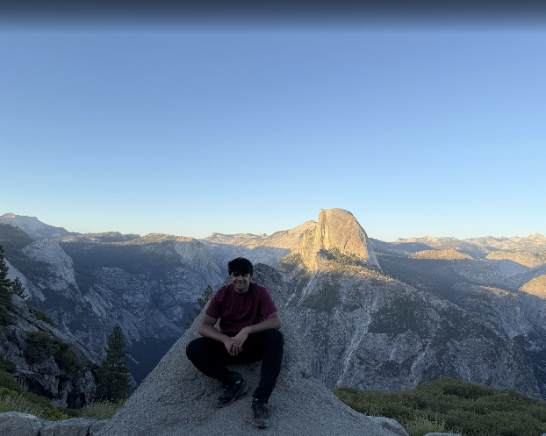

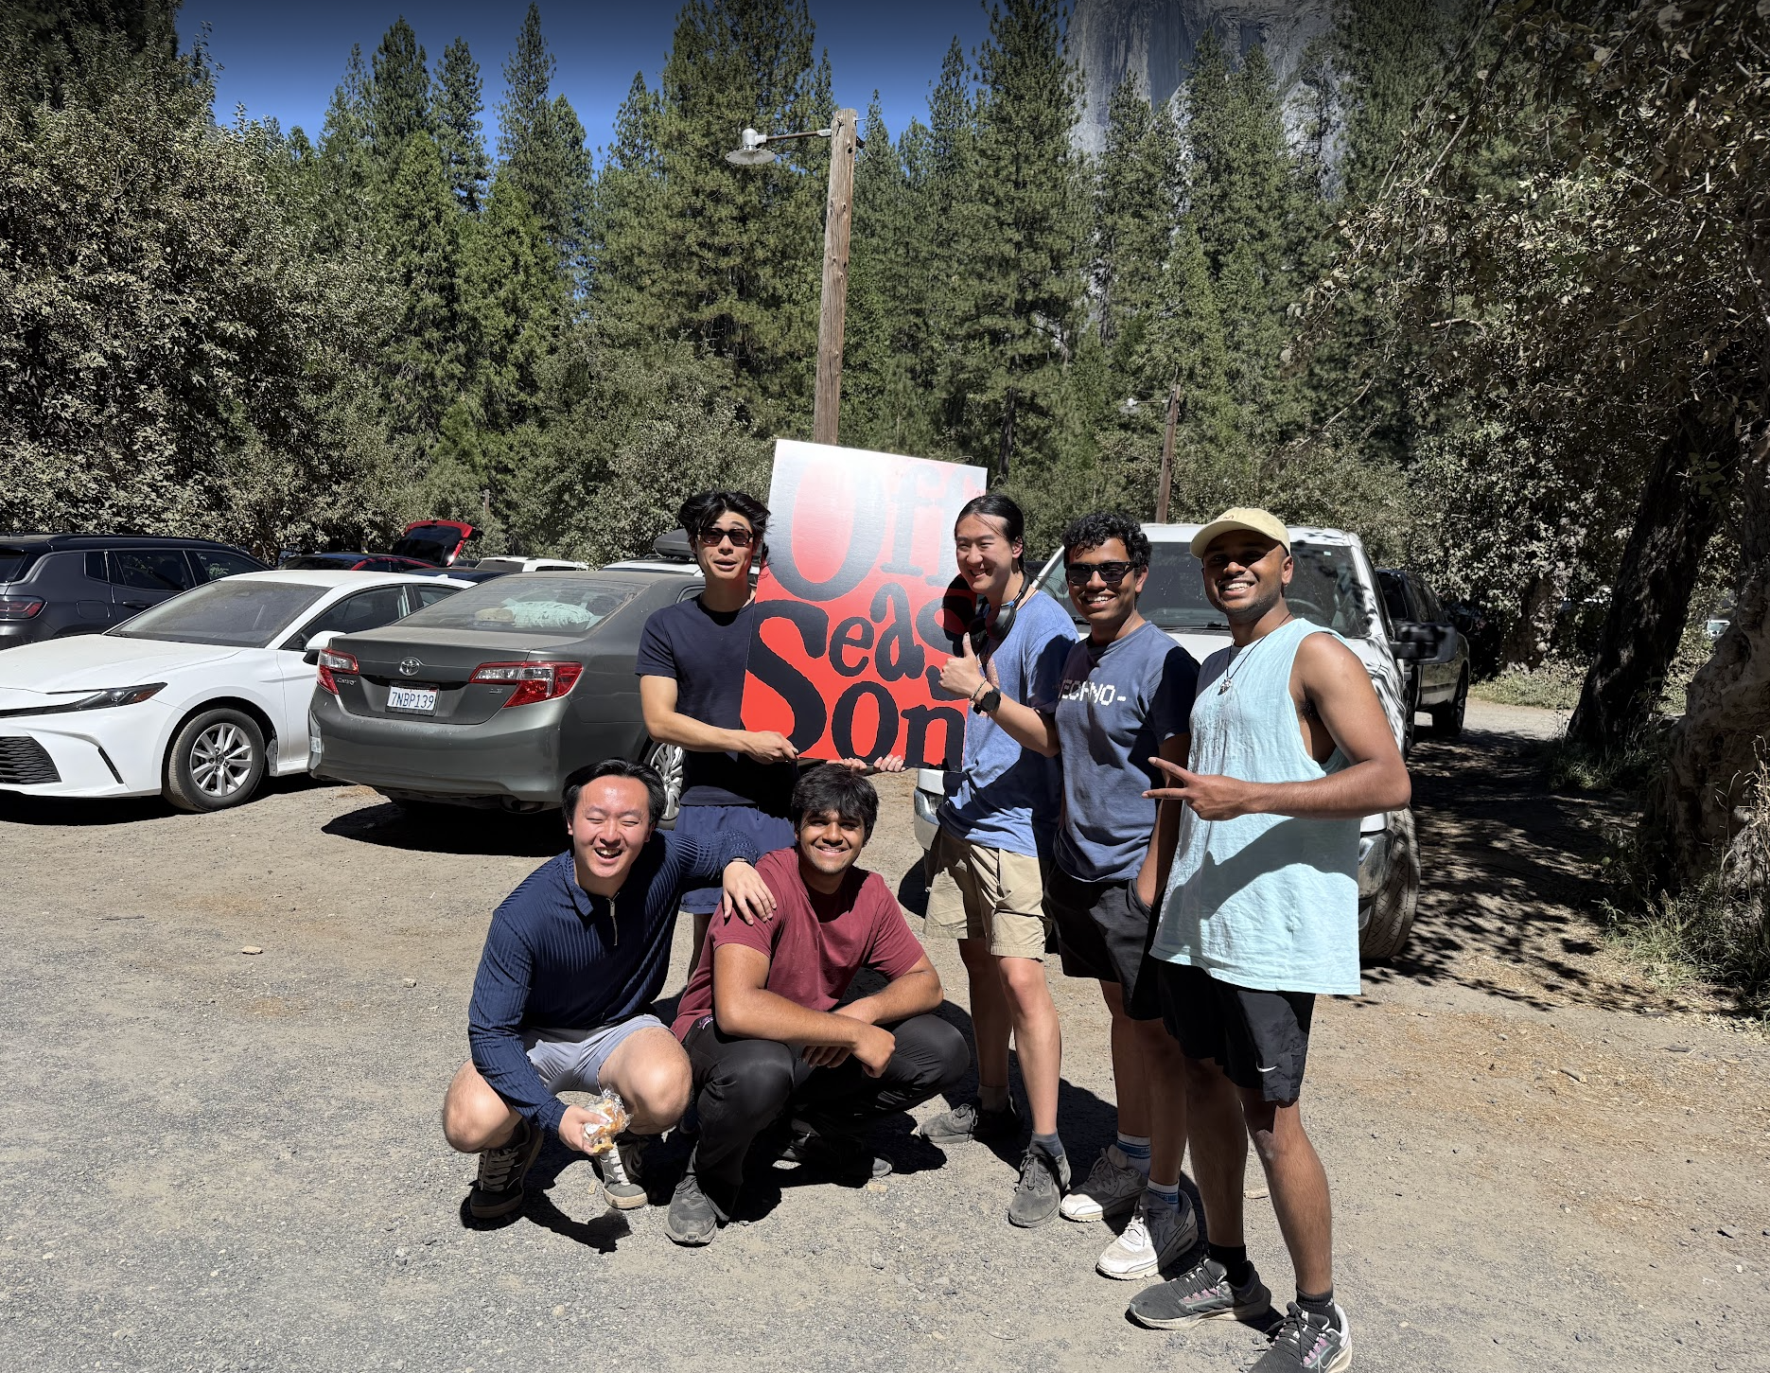

The **startup world is extremely fast paced, addicting and high in dopamine**. People are dropping out of college, raising $1M rounds, hitting $5k MRR, getting 10k users, and they are all around you. It’s intoxicating. But there may be value in slowing down and trying to accumulate the **deep knowledge** that I want, instead of tying myself to a startup for the next 5 years. At least that’s the bet I’m taking.

So, **what’s next?** I’m heading back to college, even though I’m not the biggest fan of it, and despite being so convicted on dropping out just 2 months ago. I’m going to treat it as **2-3 years in sandbox**, where I have the freedom to explore and learn anything that I want. I’ll be working hard, it will probably be lonely, but I’m fine with that, I don’t shy away from challenges.

I definitely want to do a **deep dive into physics**, I really want to understand how the universe works (or doesn’t). I want to read a bunch of books that I’ve been meaning to read for so long. I’m also going to pursue more **hardware related projects**. If you are interested in my journey, or in **deep dives on life, tech, physics and everything else**, I’ll be posting about all of that here! I hope to come back to Silicon Valley someday. I’ve changed so much in the last year, and I’m **ready to work hard again to change even more**. This is just the start.